HOW I MAKE MY DRAWINGS
Many lay-people have asked exactly how I come to the end result of my individual automotive art works. When I tell them, they are very often surprised with the total process described, thinking that I have somehow used a computer and simply colored the black and white print. My drawings are multi-media, and are all originals. Meaning, there is more than one type of art medium used and there are no copies or reproductions of any of my pieces. There is however, the exception of full-color reproductions from very Hi-Res digital photographs, which are then sent to a multi-color ink-jet printer. These are called Giclee Prints. These can be made in any size and sell for a fraction of what an original would sell for. So I will show you my typical process taken my photo images during the process using several pieces as visual aids:

STEP-ONE: I find an image I like from the internet or magazine and print to 8.5” x 11”. Using that as the model for my personalized version, I draw in soft pencil on Bristol board to usually 36” x 24” paper size like the 1940 Ford “Woodie” shown.
STEPS-TWO & THREE: Once I am satisfied with the details of my drawing, I begin refining and adding more detail with both ink pens and various shades of black gray (about 10 of each both cool and warm shades of gray) felt marker pens.
STEP-FOUR: At this stage, I am ready to add color. Showing this Ferrari as an example, I now have everything masked off with paper and clear, removable Scotch Tape, that I do not want to have the color I intend to use / spray.
STEP-FIVE: Using the ’32 Ford Hot Rod for illustration purposes, I am showing the part where I had everything not yellow flames, masked off to airbrush with water-based paint (mixed to the color I desire) and sprayed in those areas. Once dry, all of the masking tape and paper is removed. Often, re-masking is needed for airbrushing highlights in light or dark colors.
STEP-SIX: There is also much hand painting and coloring to be done using opaque Tempera Paints and colored pencil. This type of work and media-use is done both before and after airbrushing.
STEP-SEVEN: The finished drawing before adding mat board and frame. The green Jaguar shown below is from a Hi-Res digitally photographed image of that finished drawing. The professional photographer takes great effort to insure both clarity and exact color rendition are achieved. I have found that depending on size and complexity, these drawings take anywhere from 30 to 70 hours to create.

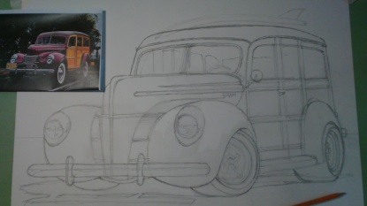 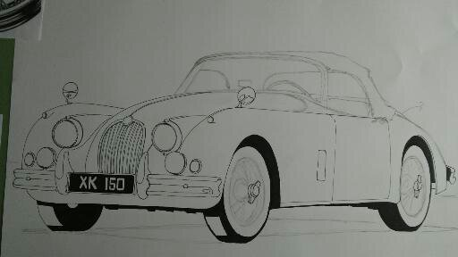 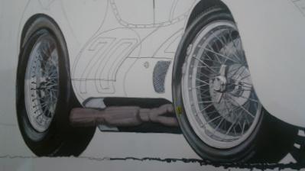 ONE TWO THREE
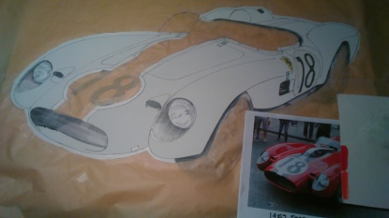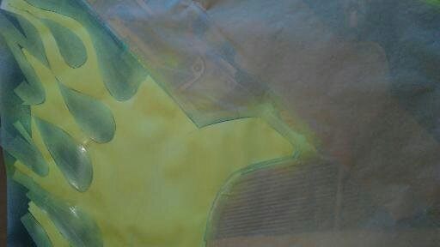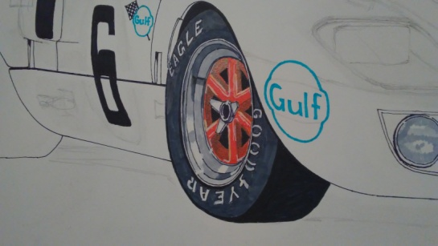
FOUR FIVE SIX

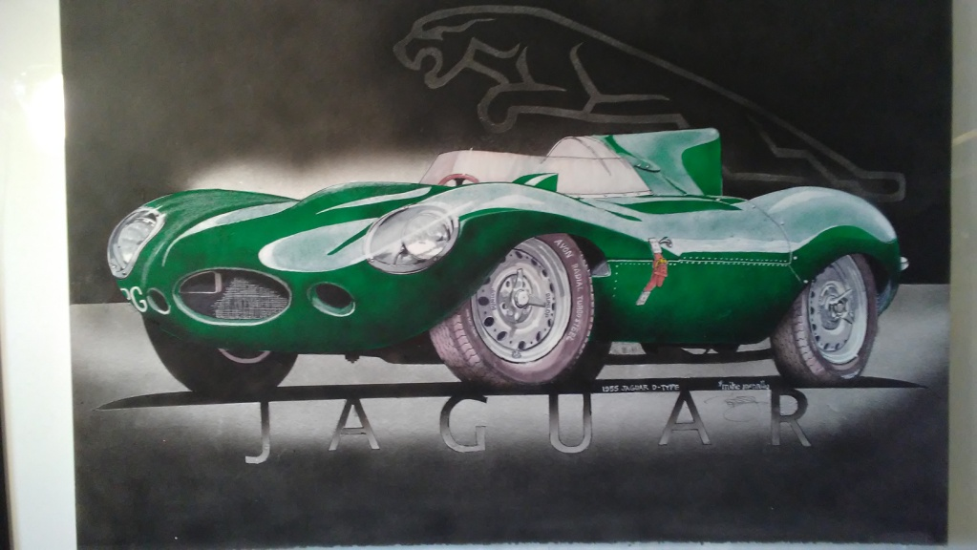
SEVEN (Hi-Res Digital Photography by Tim Fleming, Clovis)

