GERMAN FOODS
I REMEMBER
FROM MY
GRANDMOTHER’S KITCHEN

By: Mike D. McNally, Fresno, CA, 5-25-17

I have my own recipe for Beerocks as well as the recipes for all the rest of these goodies in the old 1981 Tabitha Society Cookbook made by Grandma and her other Church attendees at Salem Evangelical Free Lutheran Church. I think every relative of mine got a copy of this cookbook with the congregation’s favorite recipes. I also know from many discussions that many of my relatives on my Mother’s side also enjoyed these treats being made by their Grandmothers and Mothers. Many of my relatives still make some of these to this day.

Beerocks or Bierocks – A Meat Pie

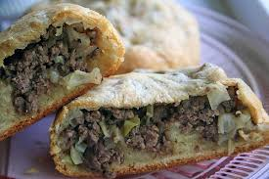
Our Grandmother Anna Adolph was considered the “Queen of Beerocks” in her German community near Sanger, CA. With the help of my Mother before she passed, I was able to get a pretty close re-creation of Grandma’s and have a recipe if anyone wants. The key is a good bread dough with yeast and a filing that has lots of meat and Onions, Cabbage and spices – according to what Grandma told me. I posted a picture of some recently made Beerocks on Facebook and got a huge response. Seemingly everybody here in Fresno has had Beerocks in their time here and many still make in other parts of the country they have moved to.

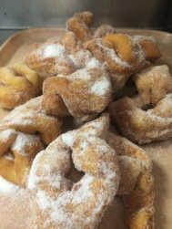
Grebles or Dehr Greble - German Style Baked Pastry

This is basically a sugar doughnut is a freestyle shape. I remember always getting a bunch in a brown paper bag with oil stained sides. A second cousin named Tommy was good at making them for family reunions.

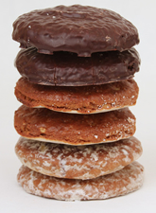
Lebkuchen – Type of Cookie

Usually around Christmas time, when Grandma was in a baking frenzy, we would often see these type of cookies.

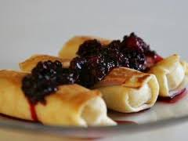
Blinne, Blintzze or Blintz – Crepe w/ Cheese Filing

Also an occasional treat made by Grandma. A very common dessert or breakfast fare made by many cultures. I use sweetened Ricotta Cheese with pureed, sweetened fruit topping.

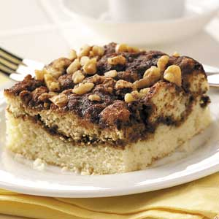
Coffee Kuchen – Coffee Cake

This is also made by many cultures, though I think the German version has it’s unique shape, if not slightly different taste. Grandma made this often as I recall.

Varnika
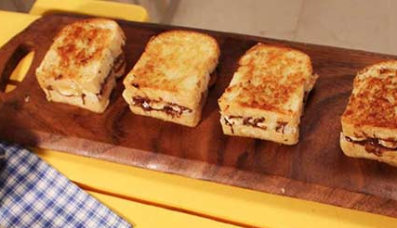
Also made by numerous cultures, I think German Varnika had its own shape and taste depending on where those populations of Germans were immigrated from. Grandma Adolph made this about as often as she made Coffee Kuchen.

