EXOTIC CARS
I HAVE DRIVEN

I have driven lots of different cars in my lifetime and rode along as a passenger in many others. Some were luxurious and some were plain fast. Some were funky and some were cool. There have been literally hundreds of cars that I would have loved to have had a ride in. Many I have only seen in car shows or in magazines, etc. The four below are cars I actually got to drive along the way. (2-25-21)

FERRARI DINO 1972+

A good friend and general contractor Dennis owned this beauty. As long as I knew Dennis, he always drove a high-end vehicle but not always an exotic sports car. He once had a Rolls Royce Corniche for example. Dennis was about the most handsome man I ever knew and when riding along with him, women would nearly break their necks following this car and his good looks. Sadly, the combination of both led to his demise. I rode along in this car many times and he let me drive it one evening! I had always wanted to buy one but when I got close to the target price, the price doubled (or tripled) due to the devaluation of the dollar in the early 70’s. Probably just as well. Not a very practical, everyday car.

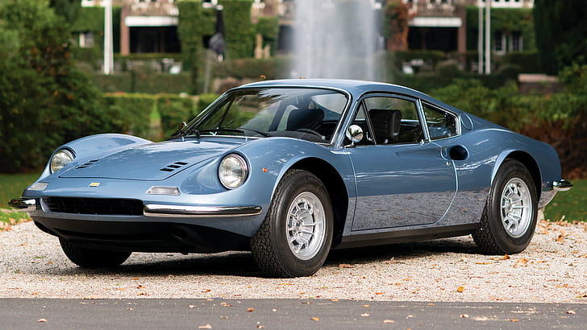

FERRARI 308 GTB +79

One evening, the husband of my wife’s co-worker and her, came over for dinner. He was driving this car. Later that night, we made a lengthy grocery run at his request for things they needed the next morning. I got to put about 20 miles on this car – some on winding mountain roads (75 mph) and some modern highway (140 mph). I was super impressed with the car’s performance and handling. He told me he had bought the car with his luck in a high-stakes Vegas poker game. Turned out, it was from running cocaine from San Jose to Monterey. It got impounded and sold by the feds and he was sent to Soledad!

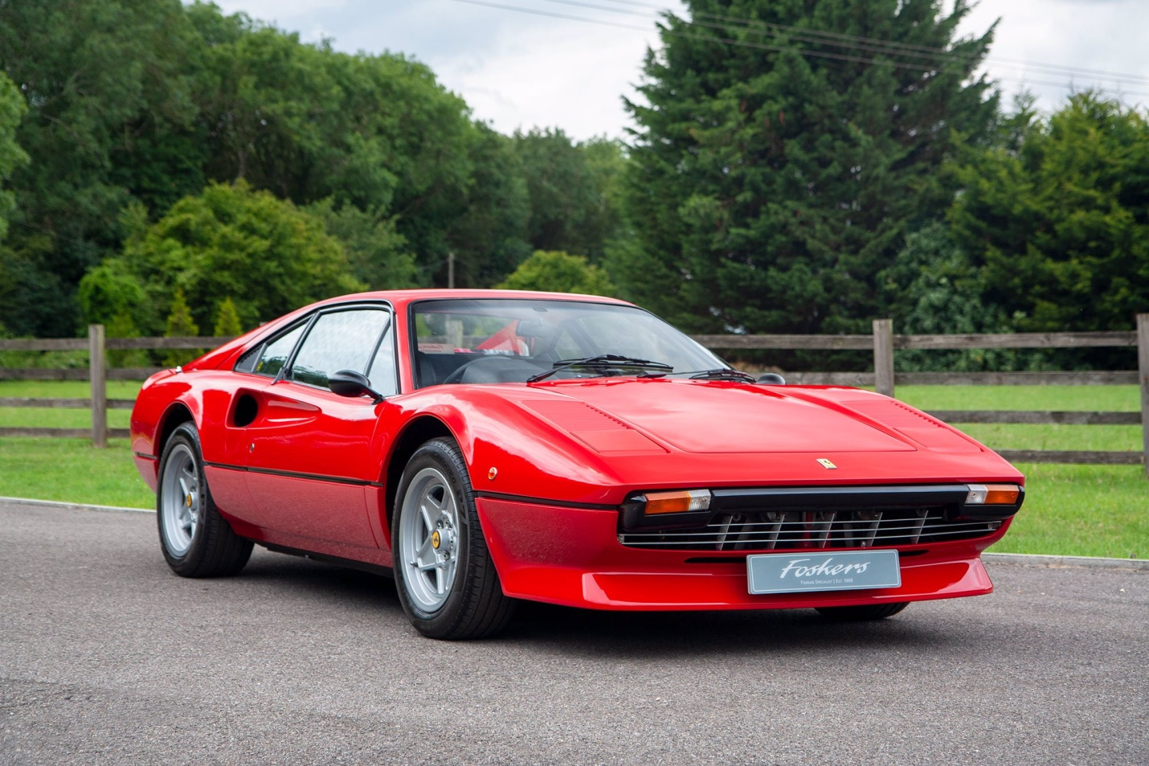

FERRARI TESTAROSSA 1976+

Another friend – also named Dennis and a general contractor, was a car buff and knew several exotic used car sales dealers in Monterey. This was a car he was loaned for a day or so to test drive. I rode with him and drove the car around town for a few hours that first day. I always liked the unique looks but was not particularly taken with the quality of the car or its performance. He also test drove a few other cars from the same lot on Del Monte Blvd., but none as classy and exotic as this one.

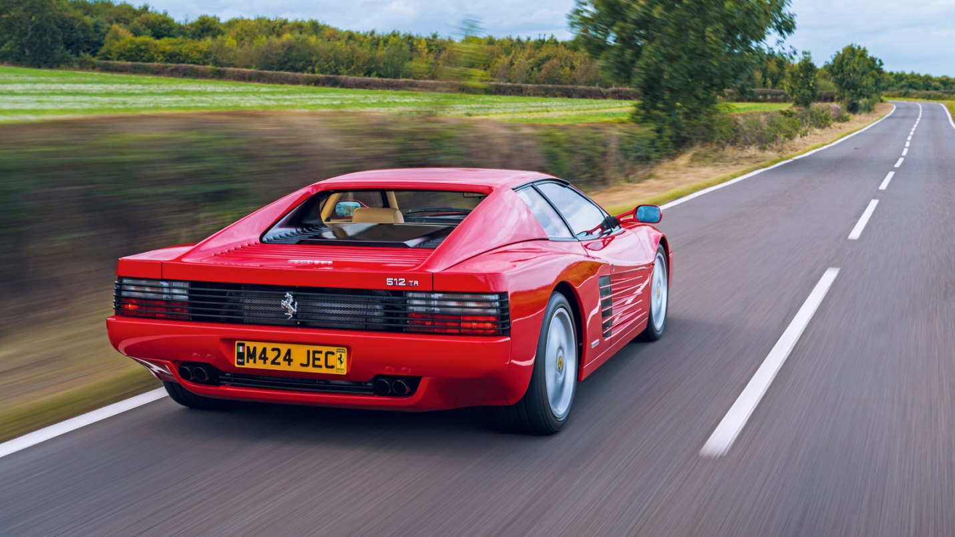

NISSAN NSX 1990+

A friend name Julio, who owned 4 restaurants on the Monterey Peninsula went to pick up his 1-yr. old Acura from annual service and walked out buying this brand new beauty out of the showroom for $105,000. I believe he got $26,000 for his immaculate Acura. He parked below my office window and beeped for me to come down to see his new car. We drove it around the Pacific Grove shoreline (80 mph). He let me drive it quite a bit that day even though he was bubbling over with boyish happiness at his new purchase. He knew I liked cars. This car was impressive all the way round…handling, performance and quality build and looks. Sadly, this car and another (Jaguar XJ6) were under about 6 feet of water in a rare flood of the Carmel River and many homes in the Carmel Mission Fields area.

