DRAG BOAT STORY
June 7, 2021
This is a story about how near I came to killing myself being a co-owner and driver of a quarter mile drag racing boat. A relatively short period of my life back then, but I think you will at least give me an “interesting” story when done even though rather lengthy.
I had always liked cars and was drawn to them since I was about 5. However, I didn’t begin getting my hands greasy until the summer of ’65 when I met my best friend Russ’s neighbor Mike. That’s where I spent an “all-nighter” helping him replace his 400 HP 352 cu.in. Ford engine in his ugly red and white ’58 Ford. From that point on, I realized I liked auto mechanics and I liked going fast in cars.
Soon after, I was modifying the looks and some small performance enhancements of my very first car – a 1960 4-dr. Ford Fairlane with a 292 and 3-spd. Yeah, it was a nothing car, but it was mine and I could make it look as silly as I liked. In the meantime, we were doing some semi-serious stuff on Mike’s ’58 and occasionally street racing it, along with frequent trips to the Raisin City Drag Strip on weekends. Eventually he relegated the car to strictly strip. That was after he ripped out the front suspension and put a straight axle in it making it look like a Gasser in those days.
Along the way, I acquired other friends with fast cars and some fast boats as well. Mike was then working full time for a local boat builder here in Fresno named Belmont Boats. Like all the other boat builders at the time, having a race boat and competing also translated to selling against your competition like Sanger Boats, etc. One late Thursday afternoon in May ’66, Mike called and asked if I wanted to go to the lake (Millerton just north of Fresno) and watch the testing and engine tweeking of their boat for the upcoming drags in Oakland. I had just finished my last college final of the semester and was eager to tag along.
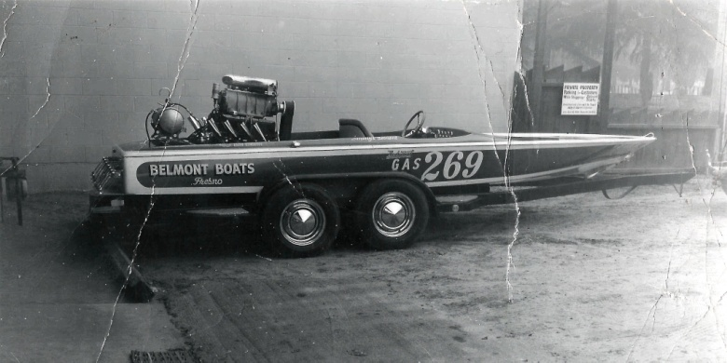
The father-son company had an 18’ “Flat-Bottom” drag boat with a 427 Blown Gas Ford that occasionally ran 116 mph. We all met on the West shore and had the entire lake to ourselves that weekday afternoon around 5 PM. No wind and the lake was totally glassy and calm - Perfect for high speed testing! Lenny, the son and about my age was the driver but they had a second bucket seat for two ride-alongs by the company mechanic (Also Mike as I recall). I watched in nervous glee as the first two up and back blasts were made. When the third test run was to be made, Lenny offered me the chance to ride along. Not wanting to be seem the coward in front of a dozen grown men, I tentatively agreed.
Lenny stressed how I was to grab the bottom of the plywood dash and never let go – no matter what. Once outside the buoys, he aimed the boat North at the center of the lake and put his foot down on the aluminum gas pedal. The boat’s ass end jumped out of the water as they are designed to do, resting on nothing but the rear flat bottom area, gravitation plate and about the bottom third of the special racing prop. Up and back she bucked and bounced and as they call it chining like it is going to flip over any second. The blower belt was screaming at my left shoulder, my butt was trying to ride up in the temporary bucket seat as I grabbed the dash board with all my might, my eyes were watering and my heart was pounding away, while my brain was convinced this was my last moments on Earth.
I was still alive and now weak-kneed once again back at the familiar shore, and exited the boat wobbly while Lenny casually claimed we did about 112 mph. I had survived and I liked this fast boat thing and the adrenalin rush. Though, at the time, I never thought I would be the builder and owner of one like this someday soon.
I managed to buy a friend’s 427 Ford Galaxie and became part of the local racing scene both on the street and strip. A lot of my friends also had fast cars and/or racing machines of some kind – cars, boats, motorcycles, etc.
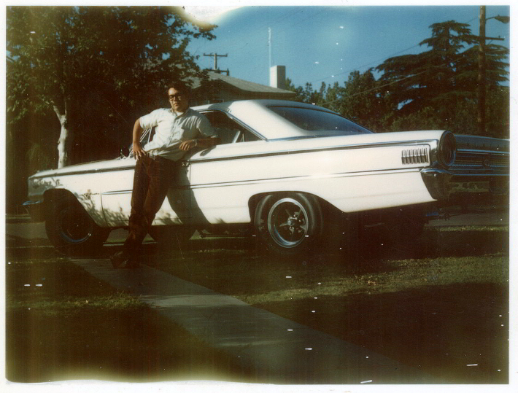
Stories about my street racing days and the lifestyle that the movie American Graffiti captured, will be left to another time. Needless to say, I am extremely lucky to have survived those childish days and can claim I never hurt anyone in the process or ever got a speeding ticket!

My best friend at the time Mike was now working for the west coast’s prestigious Sanger Boats in SW Fresno in their race boat division and he was going with the crew occasionally on weekends up and down the state for drag meets. He and I had talked many times about building something to go serious racing with. We settled on a B/GAS drag car to be fabricated out of a ’64 Falcon Sprint with a 427 Blown Gas Ford SOHC motor. We had 4 of them still brand new and in crates located in Washington State for $400 each. I’m guessing you probably couldn’t buy and unused SOHC crate motor for less than $50,000 today if you could even find an unused one? Anyway, we were pretty clear on what we were going to build. My drawing of our dream idea is below:
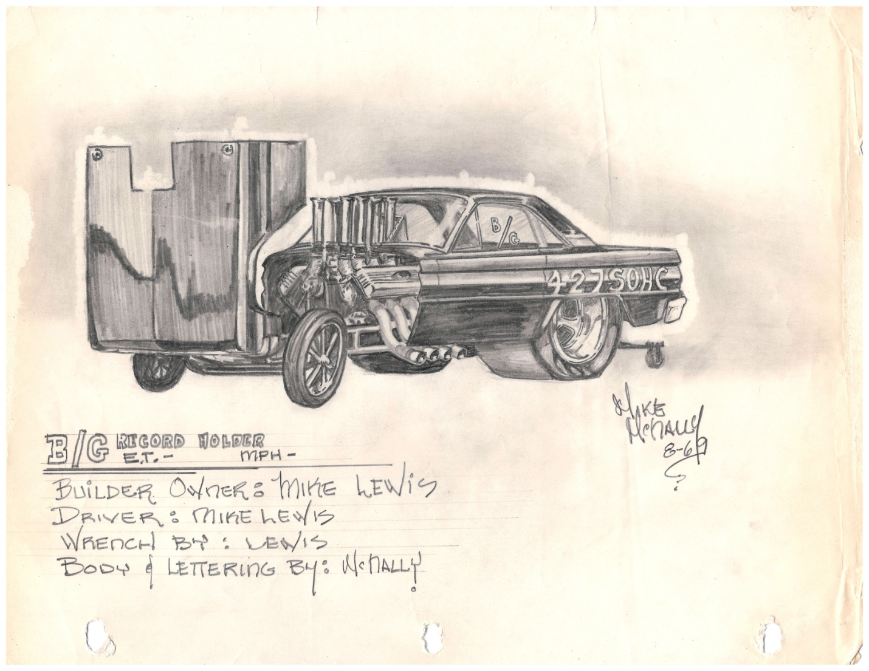
As Mike and I were nearly set late ’69 to build this 10-sec. drag car, Mike insisted that I go to at least one boat drag to see if I might not want to build a boat instead. No more getting greasy. No more lying on the ground with the ants and dirt in our hair. Matching uniforms were the thing and lots of bikini-clad fans to fawn all over the boat owners and drivers! I went with him to Oakland Estuary and was hooked, seeing for myself, what he said was true. And since he worked in Sanger’s race boat division, we got everything at cost plus had the entire shop at our disposal, not to mention the company logs on all the other successful boats they built and worked on.

Unfortunately, I only have this to show what we had planned to build and explain what became of the project.
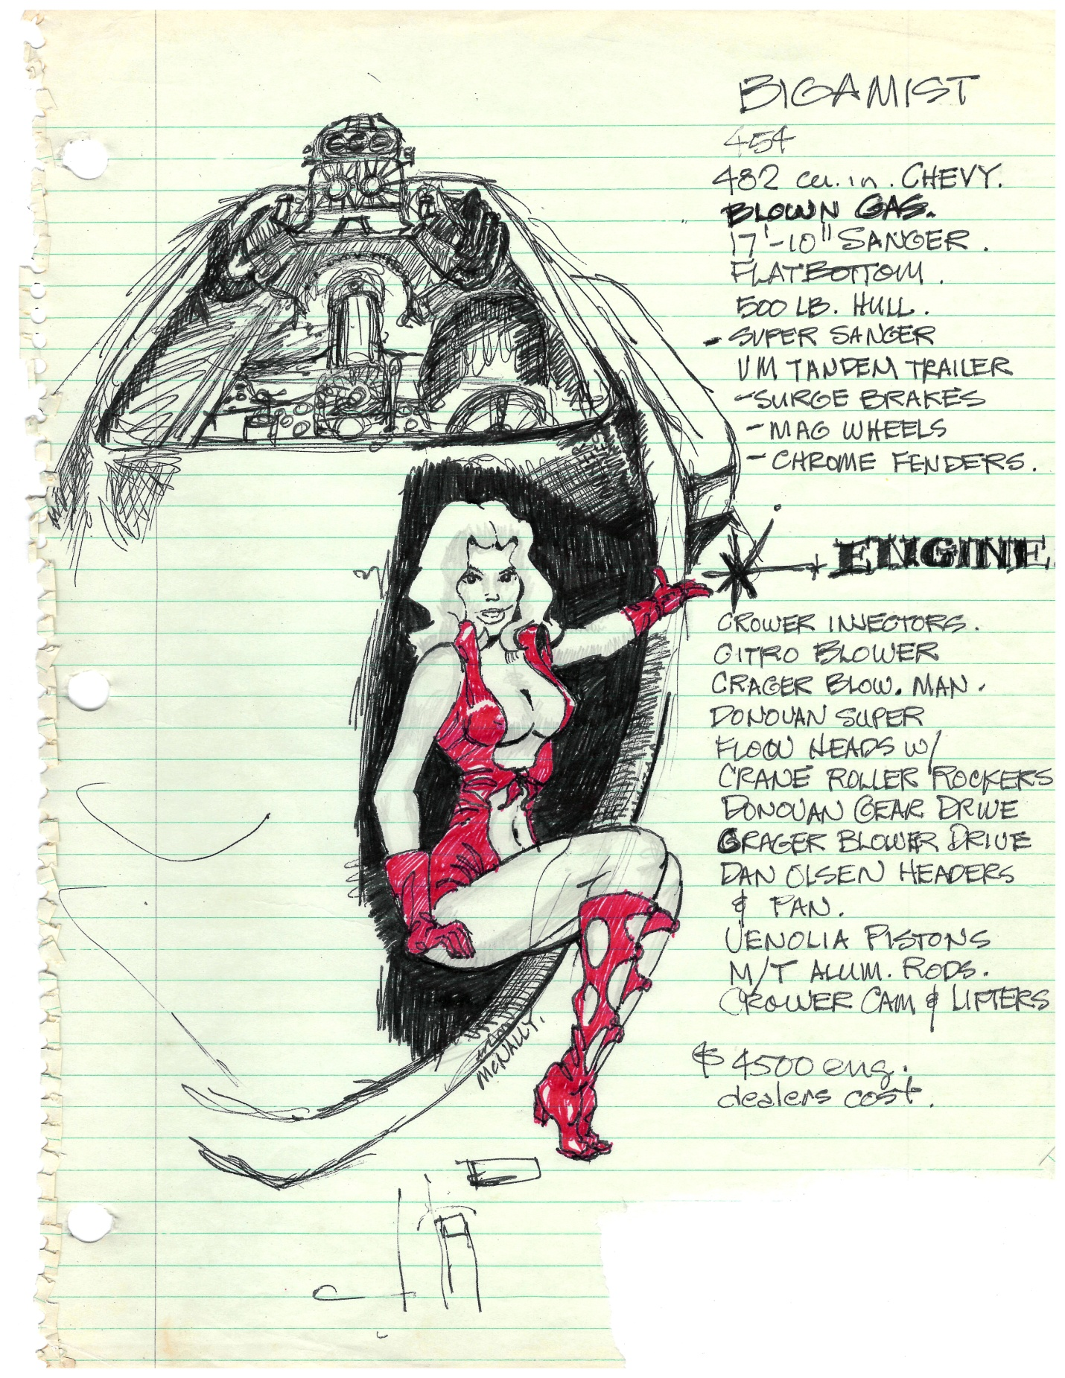

I think what was an unusual thing and boon to us, was that we had two log books carefully stating exactly how every race boat was built and set up at Sanger Boats. To that point, no one had ever bothered to consult that treasure trove and mine the commonalities of the successful boats that Sanger had built to that point in time. We dutifully noted where the V-Drives were located, what angle, what brand. Props used, hull thickness, driveshaft angles, etc. We could easily see there were commonalities of all the winning boats and no one yet had bothered to research this. Along with these winning facts in our favor, we spent many, many hours over late-night coffee in Mike’s garage or Sambo’s Restaurant. That was the popular place for us and our friends to gather in those days before the name was deemed racist and ceased to exist. It was right on the SE corner of Blackstone and McKinley. Now a gas station and convenience store.
We started out with a bang and made really great progress. The first thing to happen was the fiberglass and wood hull that Sanger made on the premises. The owner gratefully sold that to us for cost. Mike and I spent a whole weekend “blueprinting” the bottom of the flipped hull when the fiberglass shop said it was cured enough. We used a half inch thick plywood base instead of the usual 5/8” or 3/4” - Dangerous, but adding lightness to the build – our guiding mantra where possible.
Our long-time friends at Valley Muffler (VM now) were relocated south of Fresno and building tandem-axle trailers that were considered the best in the business at the time with their new surge brake idea, which they also gratefully made for us at cost. Again, Mike and I discussed every single aspect of our build and every single detail. I sketched our ideas and we refined and built all our own brackets out of aluminum in Sanger’s shop many long nights. The boat began to come together. All that was left to do at this point, was build the engine.
At this time, each of us had close to $10,000 invested and we were about 2/3rds complete. The locally-known and famous race engine builder Dan Olsen had a speed sales shop with our friend Art Voorhies managing it, where all our engine parts bought we were allowed to buy at cost. Dan built the 2 ½” “zoomies” and the 11-qt. oil pan on the premises. He was also going to build our short block for no-cost. Dan built motors then for Sanger as well as unlimited hydros back then like Miss Pay-N-Pak, etc. It was here I am sorry to confess this loyal Ford fan was convinced to switch to a big block 454 Chevy. Why? Because Danny convinced us everything we needed was A. Available, B. Much cheaper, and C. Already proven to allow us beginners to easily compete.
I was to be the driver at that point, though I had never, ever driven a boat more than 40 or 50 mph. And that seemed ungodly for being on the water! Mike was married and had a 5 year old daughter at the time and I was unattached with no commitments. I would learn the hard way how to eventually drive this beast we were building.

In the early summer of 1971 as we were beginning the engine build and buying parts for it, I lost my job at the architectural firm I had been with for about two years. I was anxiously waiting for an architect friend to open his new office and was forced to give up and take an offer in Pacific Grove on the Monterey Peninsula in Nov. of ‘71. I told Mike it was only going to be 3 or 4 months until my friend brought me back to Fresno and I could continue with my share of the money and building.
My friend never opened an office and I came to like living near Carmel Beach and working in Pacific Grove. Around late spring of ’72 we talked on the phone with him insisting I come back and finish our pact of seeing the project to the end. I told him I loved the new job, the area and had found the girl I was going to marry. Because I had broke my promise though, I gave him my half outright.
It took him another year and a half to finish the boat on his own and tested it at Pine Flat and Millerton enough to know the boats characteristics. He then took it down to Bakersfield’s Lake Ming for his first boat drags. The record by then was now 119 mph for a Blown Gas Flat Bottom in the quarter mile. In order to set a new record, you had to better the speed by 2 mph and back it up with a second run within a half mph of the first run. Also, Mike was qualifying to get a pilot’s license that required two successful passes abiding by all the rules and doing nothing wrong.
Mike and I always expected the boat would be capable of about 120 to 122 mph and perhaps set a new world record. Mike made only two passes that Saturday; 119 and 119 ½. Here was a brand new boat (“Bigamist”) that most knew nothing about or him for that matter and had equaled the world record straight off the trailer, qualifying for Sunday’s runoff heats. Everyone was shocked by this brand new boat and driver.
He put the boat of the trailer, drove back to Fresno and never again put the boat in the water. He later told me after I moved back to Fresno in late ’98 that he only had his foot in the gas about half-throttle, and that he was sure the boat would have gone 140 or killed him. He said it scared the crap out of him. Later he bought a used dragster and used the engine to go dry-land racing and sold the boat and trailer. All the while listening to his story and inwardly being thankful I didn’t stay and become the driver.

