CARS THAT I HAVE OWNED (Or DRIVEN) March 1, 2016
This is a list of all the cars that I have owned, and, where possible, actual similar pictures of cars that were taken from the Internet.

The first car that I actually drove by myself was my Dad’s 1963 Ford Country Squire Station Wagon. It was a medium metallic green with faux wood siding (“Woodie”), 390 cu.in. w/ automatic transmission. I had talked him into leaving it along with keys on a Saturday during the summer of ‘64, so that I could wash and wax it for him. My scheme all along was to time it just so that when my Mom normally walked to Wanda Preble’s house down the street for her normal Saturday afternoon visit for 1.5 to 2 hours, I could be out driving. All worked well – Mom walked to Wanda’s and five minutes later, I was out being cool, driving around the neighborhood in the freshly washed and waxed chariot. I figured 45 minutes would have me safely back in the driveway long before Mom returned. Not so, as she was standing with hands on hips at the head of the drive when I returned. Yes my Dad was mad. No license was a dangerous opportunity for an accident and a serious liability suit, resulting in financial calamity for both of the business owners of CBM.

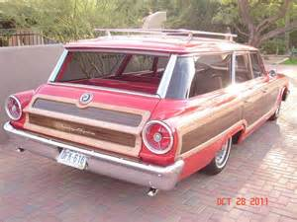

The first vehicle I drove on a legal and regular basis was a 1963 Ford Econoline Van. It was a plain vanilla (Wimbledon White), windows all the way round, 6-cyl., 3-spd. on the column and no interior upholstery other than the two seats on either side of the engine compartment. I began driving this vehicle in the afternoons after I returned home from school in the latter half of my senior year in early ’65. I normally delivered (also some Saturdays) for about 2-3 hours each weekday for California Business Machines, and drove it home afterwards. I continued to drive and deliver for another two years. Tim and Gary also drove this and a newer Econoline after I quit delivering. I enjoyed driving this van to Fresno City College and took it many times up to Dinkey Creek with Tim and friends for a two-day camping and Huntington Lake dance trips. I always kept it cleaned and waxed and also had a mattress in the back. My reasoning of course, was to keep the adding machines and typewriters from sliding around on the metal floor and banging into each other. The red film I put in the two dome lights had my Dad of course wondering about my true reasoning!

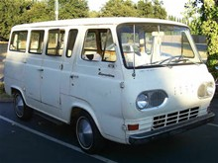

My very first car that I actually owned was originally my Mom’s third car (A 1950 Pontiac Fire Chief and a 1950 DeSoto). It was a 1960 Ford Galaxie, Canary Yellow, 4-door Sedan. It had a 292 cu.in. Y-Block V-8 with a 3-spd. on the column and bench seats. My Dad had bought it used from Northrup King Seed Co. of Fresno, having been a sales rep’s car for 3 years. It had a 1.5” hole in the center of the roof that was a CB antenna location, which I never bothered filling. Naturally, there was always a water stain on the ceiling’s headliner of about 8” diameter, and was always the object of teasing by my friends. I bought the car in 1966 from my Mom for $300 and drove it for about a year or so. I began doing body repair, which I did not how to do and had numerous bondo’d spots that I tried in vain to sand down and spray painted with flat black and gray primer giving the car a “spotted” leopard appearance. I also raised the body – mostly in front, removed the front bumper, put 5-spoke American Torque Thrust wheels in front and deep chrome-reversed wheels in the back with wide, tall tires. Racing decals on the two side backseat windows and new plain black vinyl upholstery and an 8-track tape, and exhaust cut-outs completed my hot rod. A guy by the name of Bob Shockley bought it from me for $400. For some unknown reason, he proceeded to spray the entire car flat black. Seems to me I recall he also was studying to be an architect someday.

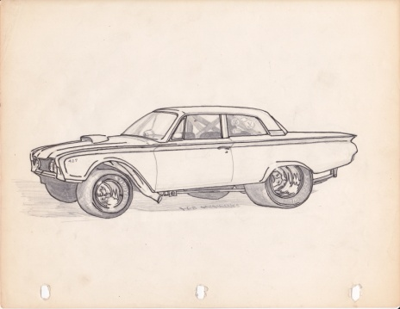 A drawing I did of the car but slightly exaggerated. Mine was a 4-Dr.

The second car I bought next became my all-time favorite car that I owned and had so much fun with. A fellow Ford fan named “Sparky” Anderson was about to head off for Army Basic Training and was hoping to find a fellow Ford lover to sell his car to. Sparky worked at the Chevron station on the NW corner of Weldon and Blackstone, so I knew him well, living not far away and buying gas there often. In the spring of 1968, I bought his car for $1,000 cash. I was working since the summer of 1967 fulltime for a Building Designer, living at home and paying parent’s $25 a week for room and board, so I had been saving money pretty easily. This car was a 1963 ½ (mid-year model designed for Nascar circuit) Galaxie 500 XL, 2-door hardtop. It also was a Wimbledon White with medium blue vinyl interior and two bucket seats. What appealed to me most were its appearance and engine / transmission. It had a 427 cu.in V-8 bored out 0.10 (431 cu.in) and a Borg-Warner T-10 4-spd. with synchromesh gearing. It had two Holley 750 cfm “double-pumper” carburetors on a low-rise aluminum intake manifold, and was putting out somewhere over 425 HP when I bought it.

Not long before I bought this Galaxie, I had come close to buying a genuine used 1966 Shelby 500GT Mustang from a local used car dealer for around $4,000. Unfortunately at that age (19) and with no credit record, I could not qualify for the necessary car loan even with a sizable down payment. My Dad agreed to co-sign, but Mom said “no” citing I would kill myself in it. It was used and in need of much TLC. It was the typical Shelby Navy Blue with a white racing stripe down the center. Had I bought this car, returned it to near showroom condition and kept it all these many years, it would likely be worth anywhere from $150,000 – 500,000. I bought the equally powerful Galaxie shortly thereafter and obviously, never did kill myself!

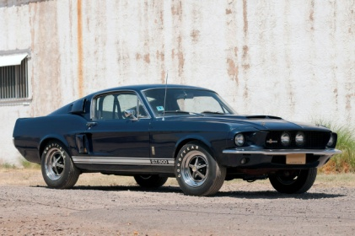

Not long after buying the 63 ½, a friend driving my car (I was drunk and in the passenger seat), over-revved the engine on a drizzly night trying to race a piddly 327 Chevelle from a stop light. He had spun a rod bearing, requiring me to take the engine out and re-build it. I went all through the engine, having it align-bored, crank balanced, all new bearings and seals, new Venolia 13.5:1 compression forged aluminum pistons with Teflon skirt buttons, new ¾ Ford Hi-Perf. Racing cam, spending about $800 at the time. I estimate I picked up about 100 extra horsepower for the money and effort, making roughly 525 HP. I was one of the top five fastest cars on the street. I never got in an accident, never hurt anyone miraculously and never got a speeding ticket. Imagine over 100 MPH on Blackstone Avenue racing in ront of Manchester Center? I only got beat once on the street by a 1969 Mustang with a highly modified Boss 428 engine (Shaker Hood). He got way better traction than I did with my hard compound Nascar 10” wide tires. I sold the car in 1970 to help finance my share of the drag boat my friend Mike Lewis and I were building. I found a stock 390 cu.in engine at a wrecking yard for $200 and swapped out the motor, selling the car for $1,200 and the separate engine to a man who put the engine in a ski boat for $600. I bought a 1964 T-Bird with part of that money - Regretting the sale of this car to this day!

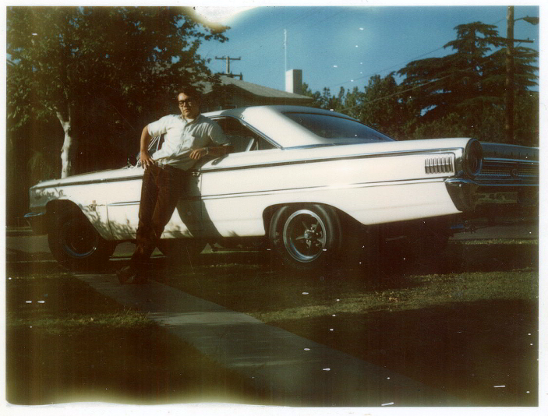

As I mentioned above, my next purchase, was an “as-is” 1964 Ford Thunderbird I had bought from Mike’s parent’s used car lot in SW Fresno for $1,200. It was a medium metallic green (A color I swore I would never have on me after Army Basic Training in 1969), with a black, very stylish and comfortable interior. It had a basic 390 cu.in. motor with an automatic. I drove this car from the fall of 1970 until I bought my first new car in the fall of 1972. Not many weeks after I bought the car, the transmission gave out and I paid Mike’s parents an additional $600 to repair this recently purchased car. I was quite angry over this and never did forgive them for not covering the problem that happened so soon after purchase. The only thing I did to this car was put four 5-spoke American Torgue Thrust wheels on it. I sold this car to Marc’s buddy Scott Lardsen for $1,000 as I recall in 1973. I almost bought a Hertz 1972 Thunderbird rental car for $4,200, but changed my mind because of the OPEC Oil Embargo and the rising cost of gasoline and lack of gas availability. At that time, I was making many drives up to see future wife Pat in San Francisco and monthly trips to Fresno for Guard Drills and holidays with family. Marc told me Scott drove it off the Tollhouse Grade road into a large granite boulder and totaled it. The boulder apparently saved their lives by keeping them from falling another 1000 feet or so!

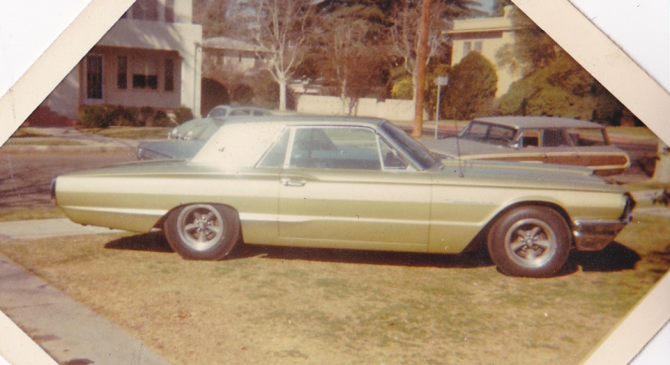

My fourth car and very first new car purchased was a 1973 Pinto Country Squire Station Wagon. I had given the Monterey Ford Dealer (Beattie Ford) $99 extra for the black exterior paint and had them install 7.5” aluminum wheels and fat tires I had bought from Eddie’s Speed Shop in Fresno and had sent to the dealer. White and Black were not standard colors offered that year, but could be had for the slight extra. The car was assembled in Milpitas, California just south of Oakland. It had a straight 4-cyl., 2-bbl, 110 HP engine and an automatic, with all black interior and an AM/FM radio and cassette player. This was handy for my SCUBA Diving days and hauling our gear in back to our diving spots. It seems to me I bought the car for about $2,300. After I bought our new car in the fall of 1978, I kept the Pinto for my wife to eventually learn how to drive and use. She never did, and I sold it to a contractor friend for $1, who was going to put a V-6 in it after he took it north to Guernville. I put 150,000 hard-driven miles on this car and only had minor repairs. But it was gutless - Too small an engine for the station wagon weight.

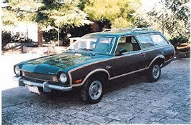 My ’73 was similar to this only I had 7.5” Alum. Wheels and wide tires.

My fifth car owned was also a brand new purchase. It was a silver 1979 Toyota Supra that I bought in the Fall of 1978. My wife was pregnant at the time with our daughter Kathleen (Born in spring of 1979) and we felt a new car for reliability, etc. was important. Originally, the MSRP was about $7,200 and after shopping prices, I managed to buy this 6-cyl. car for $6,100 from the Salinas Toyota dealership. I also leased the car for three years through my bank saving another $1,000 and having tremendous tax deductions on my business. It had a black interior and was also an automatic. This car was also somewhat lacking necessary horsepower having a 4-cyl., 1600 CC engine and fuel injection and getting about 190 HP. It could have also used a 6-cyl. motor. I later sold the car to Mike’s daughter Chris, who was working in Monterey at that time for $400 somewhere in 1990. I also put a little over 150,000 hard-driven miles on it and only required replacing the radiator for about $550 in south San Jose coming back from a business trip to SF. This was a very enjoyable and reliable car. Pat and I also took a two-week driving vacation in November of 1978, while she was 5-months pregnant up to the Northwest. Ultimately taking the ferry from Port Angeles to Victoria, then another ferry from Nanaimo to Horseshoe Bay in British Columbia and then back down to Pacific Grove. At times, Pat’s morning sickness got the better of her on this driving tour. Kathleen’s very first car ride was in this car coming home from the hospital in the mandated baby car seat in the rear seat.

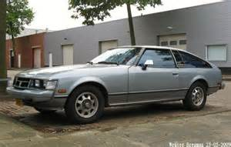

A used 1981 Jaguar XJ6, 4-door sedan was my sixth car purchase in 1988. I bought this car from a landscape contractor named Billy O’Conner, who was dying of AIDS and wanted to buy a brand new XJS convertible before he died of his illness. He had bought the car only slightly used from an old woman who had it garaged in Pebble Beach. I first saw it in his garage (nothing else) thanks to his office manager Teresa Wetle who insisted I see it. It was black with chrome wire wheels and biscuit-colored leather interior. It had low mileage and had a Kelly Blue Book value at the time of my purchase of $15,000. I paid only $12,000. Financing it through a loan from my Mom, I paid off the 3-yr., 10% int. loan in 30 months. I drove that car from 91,000 miles till it had about 230,000. I kept the Toyota for about 2 years after buying the Jaguar. I had major mechanical issues during my ownership; 2 transmission failures (Ultimately replaced with a GM T400 automatic w/ conversion /adaptor plate) and a complete valve job on the 6-cyl. 4.2 L straight 8, fuel injected motor. There were also electrical problems that plagued me down through the years including non-functioning A/C system after having it repaired and moving to Fresno in Aug. of ’98. I sold it to the owner of a body shop in Fresno around 2011 for $1,000. When it was running, it was very comfortable and enjoyable to drive. With the GM transmission in it and having an overdrive with high (3:08) rear end gears, I could cruise around 93 MPH at about 1800 RPMs.

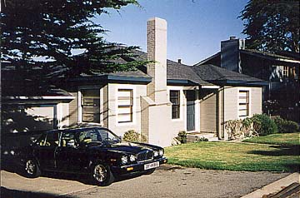 Pacific Grove House circa 1997

1983 Jaguar XJ6 was a purchase of $500 I made of a used car that did not run. It had broken head bolts and the engine was not worth re-building. I cannibalized about $1400 worth of parts for the ’81 Jag, which was virtually identical, with same color, engine, etc. Only the wheels were different – typical cast alloy instead of wire wheels. I sold the car for $1 to a general contractor, who wanted to put a Chevrolet 350 into it around 2009

1994 Jaguar XJS a used car acquired through my Mom in exchange for adding a rear deck to her Buckingham house around summer of 2006 (right after remodeling her kitchen) became my seventh car. I still have this car as my only daily driver as of this date. It is a 4.0 L, straight-6, fuel injected convertible. In the last 2 years, I have spent around $7500 on various things to maintain its drivability. It has had major repairs in its lifetime; Transmission repair, new canvas top, A/C repaired, new radiator, complete head overhaul, etc. With the exception of the A/C not presently working and in need of seat re-upholstery, it is a very mechanically sound and reliable car today and I enjoy driving it daily with the top up or down. Interestingly, the car was originally purchased by a David White of Carmel Valley Village, who owned Golden Valley Septic, a firm I had down various projects with while still living on the Monterey Peninsula. Lorraine’s best friend Billie Ruth Knapp’s husband Franklin saw an advertisement here and drove to Carmel Valley and bought it. He drove it until he died around 2002, when Billie sold it to my Mom. She drove it for about four years until buying a 2-yr.old almost new, but used 2004 Jaguar XJR, Cranberry-Red sedan in late 2006. She drove that car until her death at 87 in Nov. 2011. As part of the business, my sister Teri sold that car. Current KBB value on my XJS is about $7,100.

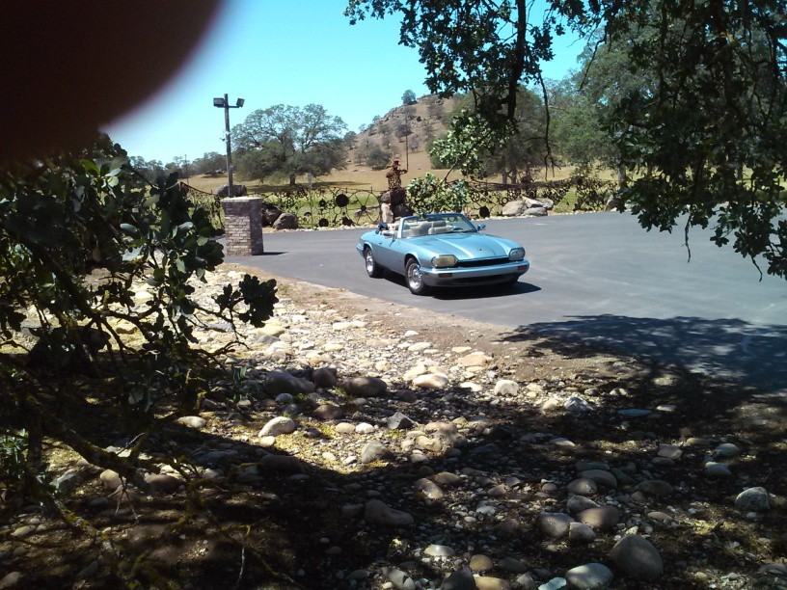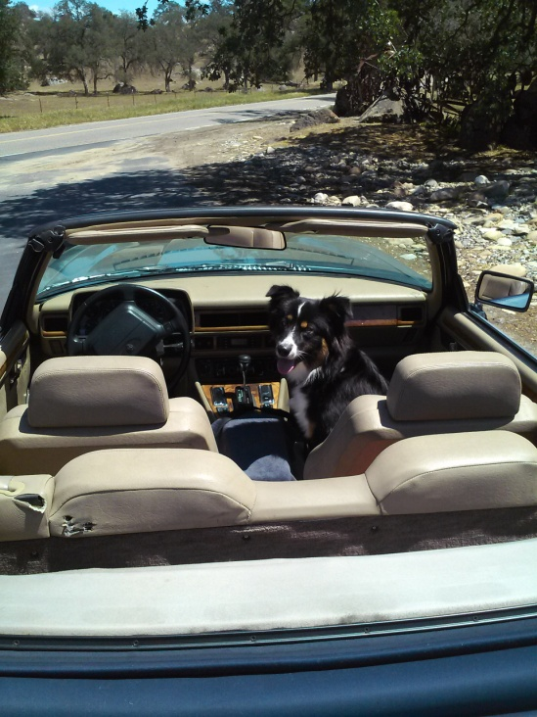

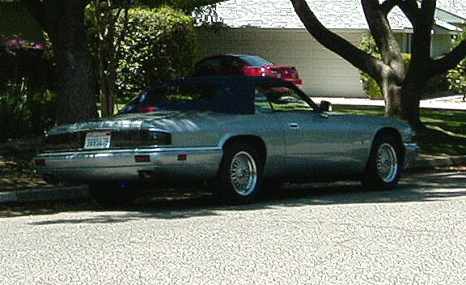

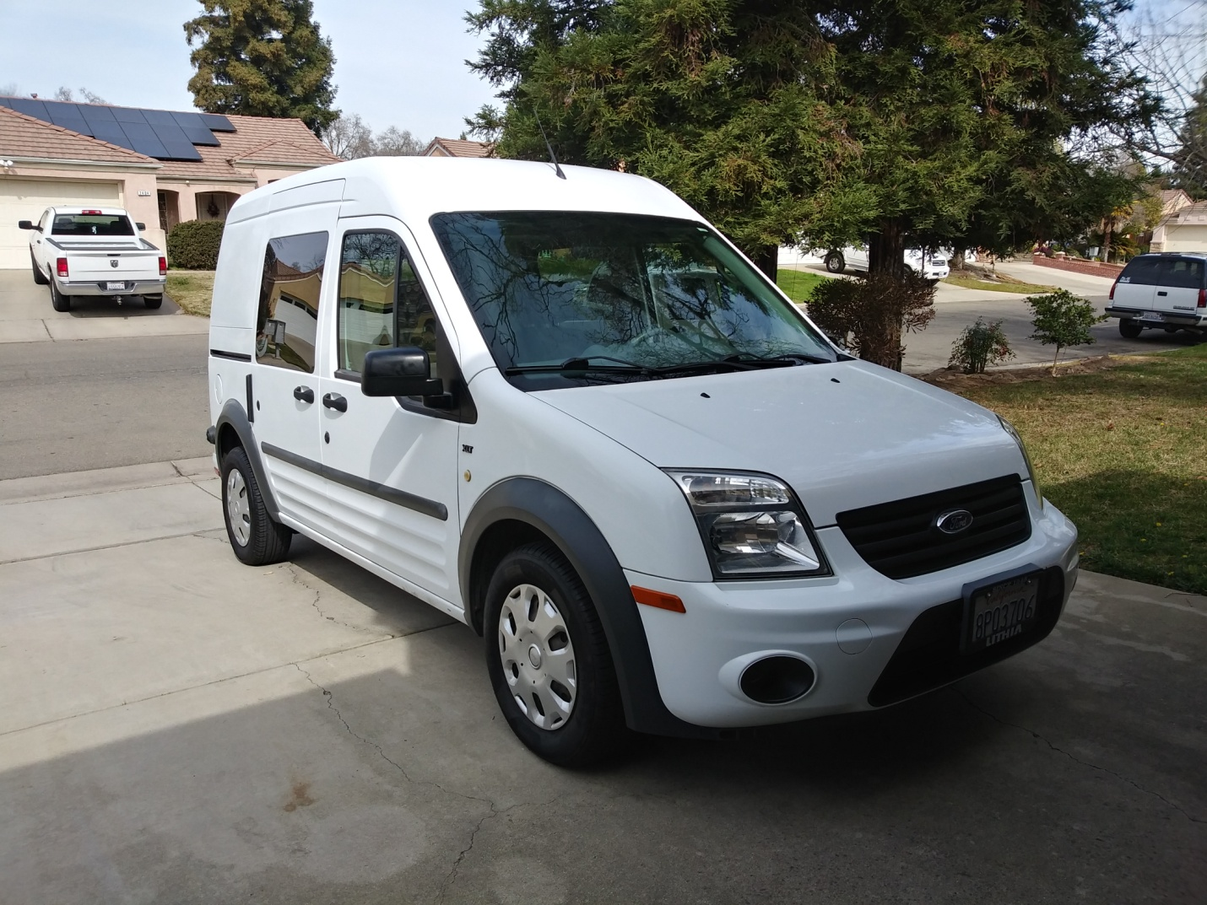

This is a 2010 Ford Transit Van that I bought in late 2020 from my sister’s business (California Business Machines). They weren’t using it and it was just sitting unused in their warehouse for about two. Because it was rarely used for the business it had about half the number of miles usually on this vintage and thus worth about $10-12,000. I paid her $3,000 for it. However, I spent about $650 to two companies to have the vinyl wrap removed unsuccessfully. I spent about 12 hours before and another 10 hours after last company finishing the removal and cutting and polishing. It has a 2.0L 4-Cyl. engine and is pretty gutless but is frugal with gas and in excellent condition with everything near new in function and appearance. I would like to get some “smoothie” wheels and baby moon caps, but they do not make anything for this zero-offset wheel design (yet). I find myself driving this all the time at the exclusion of my Jaguar. I am currently thinking of selling the Jag for that reason.

There is one additional car that I have owned. A used 1963 1/3 Galaxie 500 that I bought about the summer of 2011 from some Clovis area farmers for $1,000 (See additional Galaxie buying story). I was going to totally restore this car to another daily driver, but due to physical old-age issues and cost that would have exceeded its worth, sold it to a man from Colorado for $6,000 in Sept. of 2015. This car is presently being restored as a RestoMod in Holly Springs, Mississippi for the Good Guys Car Club for their PPG Giveaway in July 2016. I did have fun doing some work on it and contemplating and drawing what the car would look like when finished. This car was bought new from the old Valley Ford on the corner of Clinton and Blackstone by this couple for their honeymoon. They drove it for 23 years and then put it in a barn for another 20+ years.

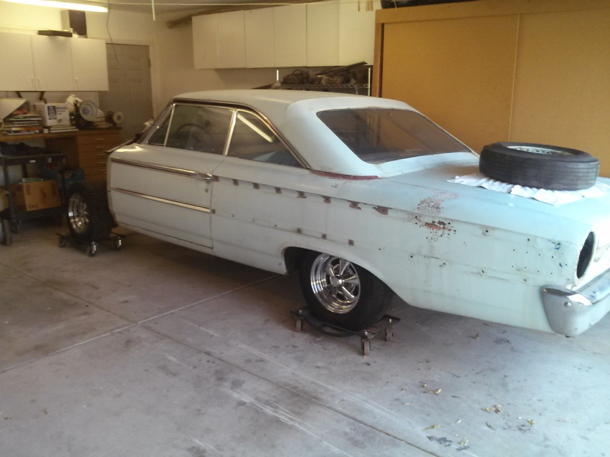

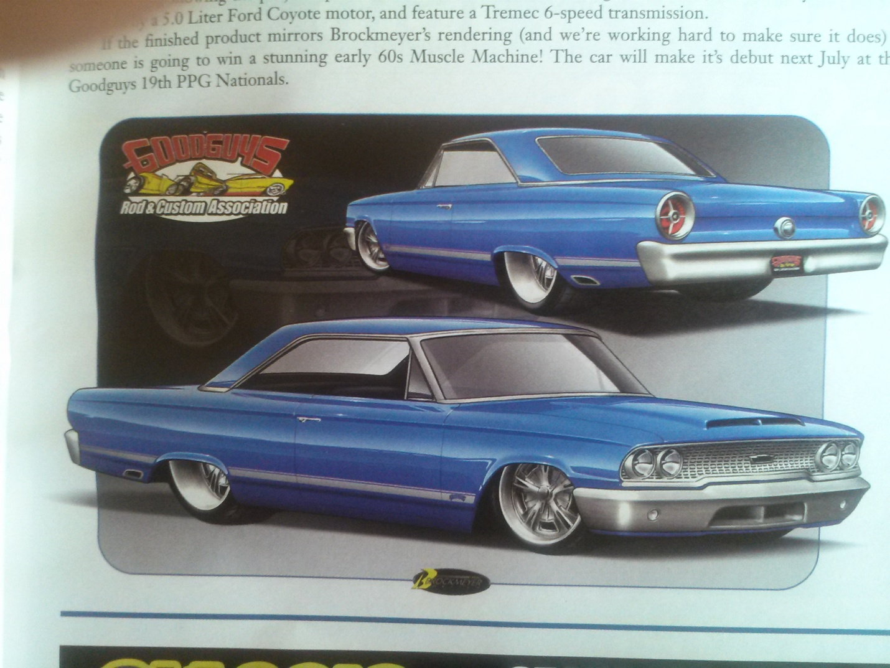

One of the first truly impressive vehicles I got a ride in was Belmont Boat’s Blown Gas Flat-bottom 1/4 Mile Drag Boat. Owned by father and son business Smittie and Lenny Weeks and been clocked doing a max. speed 0f 118 mph. My old friend Mike Lewis worked there for about a year in 1966-67, and had called me early one Thursday afternoon in the first week of June 1966, asking if I had anything to do that afternoon. The shop was going to go test the recent engine work up at Lake Millerton and I was invited. The boat was launched on the Madera side and had two bucket seats for testing so that the engine’s builder could ride along for tuning, etc. After several passes out on the lake, my friend declined a ride and suggested I might want to go along. Hesitantly, I agreed. The lake around 5 PM was perfectly smooth without wind or other boaters, so I figured it would be relatively safe. Once in the passenger seat, Lenny asked that I remove my glasses and “No matter what happened, continue to grab tightly to the bottom of the wood dash in front of me. Heading out to the middle of the lake, the small chop felt like a washboard. Lenny straightened the boat out north toward the back of the lake and without warning, pressed the pedal to the floor. Immediately, the boat’s back end rose, set and quickly accelerated to our top speed, with no further chop. As there was no windshield, my eyes were watering and I noticed the extreme sensation of speed. In a boat, I don’t think I’m exaggerating, when I say that sensation is about twice as fast feeling as when in a car. My butt was riding up in the bucket seat and I clung desperately to that dash, all the while, the blown 427 Ford, gas-fueled engine at my left elbow and slightly behind, was screaming as the 4” blower belt danced back and forth on the large pulley. When we got back to shore, I asked Lenny how fast we had gone, “Without a speedometer, I’m guessing about 110-112.” And I was to be the driver not too many years later of my co-owned Blown Gas Flat Bottom Drag Boat.
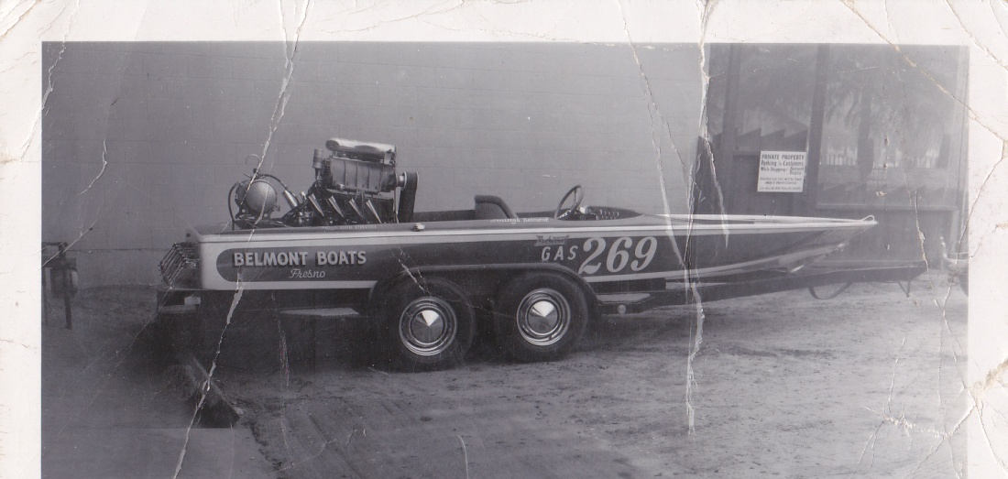

STATION WAGONS THAT MY PARENTS OWNED FROM NEW

I am not showing any sedans that he owned before or after the family station wagon days. Just the four brand new Ford Wagons shown. Incidentally, the term “Station Wagon” is derived from the new idea of building full-sized wooden bodies on automotive chassis that were used by inns and hotels to pick up guests and their luggage at stations and return.

1953 FORD PARKLANE (Might have been a Crown Victoria?)
This was the first car my parents bought brand new from the dealer. I was about 9 when he brought it home to our new house at 3117 N. 8th St., Fresno. I remember liking cars from about 4 or 5 and so this car struck as the coolest thing I had ever been able to see or get into. Additionally, it had a rear luggage area flip-up seat that my Tim and I could sit in, separate from what seemed the rest of the family. I think it was designed without concern for carbon monoxide exhaust or rear-facing effects. That which does not kill you… Also, the first car we had that had that new car invention - Air Conditioning. As I recall, every time my dad used it, he grumbled about the car overheating. He never seemed to be happy about that extra he paid so dearly for.

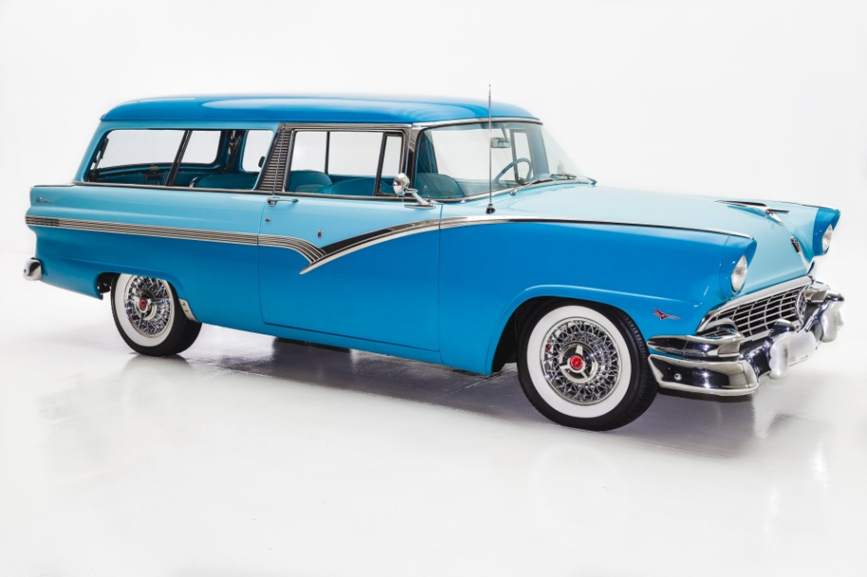

1960 FORD COUNTRY SQUIRE
Also new, though not as exciting to me as that first two-tone beauty, was our second wagon.

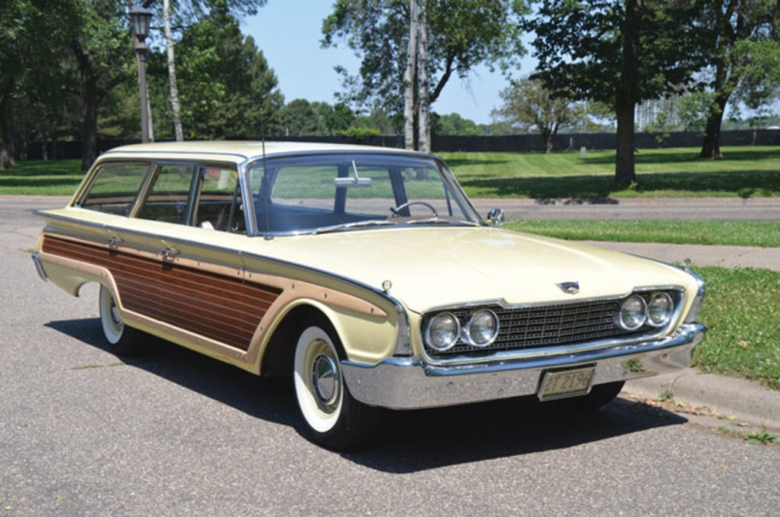

1963 FORD COUNTRY SQUIRE
I was into my mid-teens by now and this was actually one of the first cars I eventually got to drive. One time without license or permission one Saturday afternoon! Yes I got correctly admonished about that little stint! I do recall the metallic green being a little lighter than this picture though.

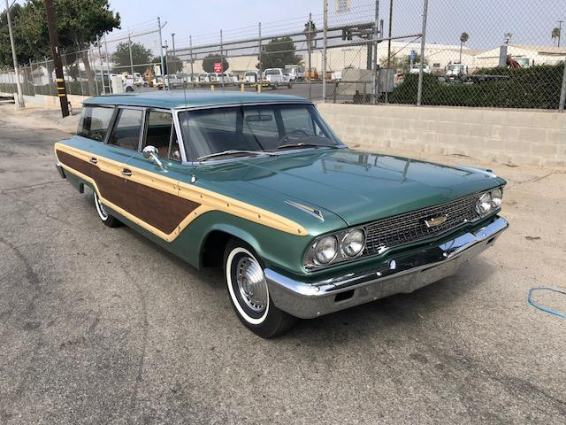

1965 FORD COUNTRY SQUIRE
This was the last of the wagons my Dad would buy for dual-purpose use in his business at California Business Machines. Instead, they bought the Econoline Van (shown above), and then bought himself a 1967 Ford LTD (Scottsdale model!). I was very disappointed in the old man car, as I almost had him talked into a Chrysler Hemi Charger with 4-spd. The 65 Wagon was really a very nice machine with A/C and all the options incl. a 390 w/ Automatic. Imagine the interior stuffed with 7 people and luggage, as well as 3 feet of stuff in the topside luggage rack headed annually to Dinky Creek cabins for a week or two of family vacation? Poor car! This was also the car that I ran against the concrete standard at the drive-in movie and tore up the entire passenger side one rainy Saturday night!

