BACHELOR AUCTION
MY STORY

I write this particular episode of my life, because it is a generally interesting story, and also, a significant part of my life. Also, I hope that someday, my daughter will read this and get a little chuckle from her father’s antics, which were taken along the way.

To begin my short story, I need to tell you I became separated from my wife and our 14-year marriage exactly at the age 40. There, I found myself right back at square one, once again with regards to women and dating. I had been off the market for over 16 years and had absolutely no clue what I needed to do to get myself back into this dating game of meeting new women. There were two rather scary things that were happening at the time that gave me pause: No.1. There was this movie playing called Fatal Attraction, where a totally obsessed woman pursued a man that had wronged her, doing unspeakable and nasty things. Enter Mike, not knowing what women were like or wanted, would I too, do something offensive enough that would elicit the wrath of a female scorned? No.2. AIDs was just beginning to become a serious public health issue in late ’87, with no one knowing for sure if you could contract the deadly disease by kissing, a simple mosquito bite or even toilet seat contact.

For a period of about 8 months, nothing I did got me remotely close to a date. Zip, Nadda, Zilch. This, despite the fact that during the previous 4-6 years while married, I had to fight off both single and married women in my circle, who knew my marriage wasn’t going well. A safe target? And, of course, they all disappeared for some reason just when I was available and wanted their attention. My brother Tim however, kept encouraging me though during these dry eight months, by telling me it was going to be okay, and that when I least expected it, someone good would come along and just surprise me. This actually turned out to be true, but as it turned out, later, rather than sooner.

In late spring of ’88, a former neighbor friend told me about a bachelor auction coming up and that she strongly felt I should become one of the bachelors like her boss had. She really pushed me into it, since I neither felt brave enough for my imagined public exposure, nor handsome enough to stand side by side with Monterey Peninsula’s most eligible bachelors. But my neighbor Cheryl coaxed, wheedled, cajoled and somehow, got me to agree. “After all, it really was to benefit some very good causes at the end of the day.” she reasoned.

Before too long, a professional female photographer named Rocky came to my office wanting to take pictures of me to use in the upcoming catalog. Shortly thereafter, a $5 brochure was on the sales rack, and calls from friends, both male and female began calling with all sorts of questions and jibes.

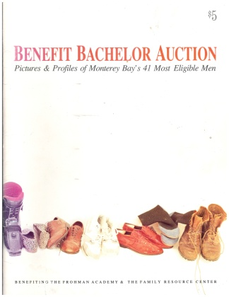

She also handed me a form I was to fill out to be used for my sales ad in the brochure that would encourage women to actually want to put down their hard-earned money to buy me along with my “date package”. One more surprise; we were also supposed to provide the date package on our own dime! No one told me that! And me, a recently separated person, trying to support two households and run a new business! Oh. And compete against guys, who I already knew were quite well off as well as really good looking! But there I was, in black and white, taking a full page for my sales ad about 3/4th the way back among 40 other bachelors! Reading some of the other 40 bachelor’s offered dates, I found some literally spectacular relative to my date and some less so. I felt confidently in the middle.
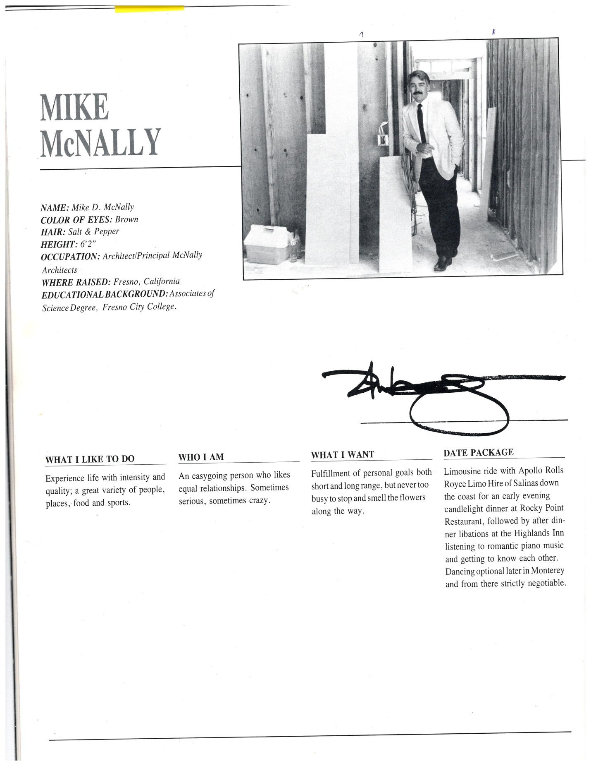
The big day - June 10, 1988 at 6 PM. Yikes! What had I got myself into? I had rented a tux, changed at my office that afternoon and had a stiff Scotch listening to my employee’s cat-calls and encouragements, before I slipped out of the office, headed for downtown Monterey and the Sheraton Hotel and the 5 PM pre-auction bachelor briefing.

When I got to the second floor or mezzanine level, they directed us to two large, connected meeting rooms where we shook hands and were given drinks and hors d’oeuvres. I knew about half of the bachelors and found the other half friendly and surprisingly, as nervous as I was. I don’t recall one that didn’t have a clammy hand shake. We drew numbers out of a hat for the order we were to go on stage. My number was 39 out of 41 men. Not a particularly good beginning I felt, thinking it would be best to go sooner than later. Initially, get it over with quicker and secondly, to maybe get a good bid while the buyers had both money and enthusiasm still left and they maybe had forgotten about those super studs with the trip to Paris aboard their own jet.

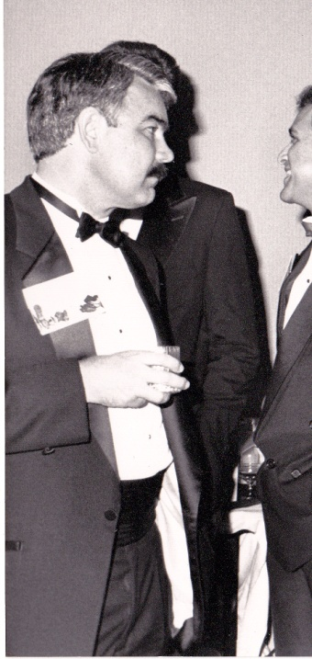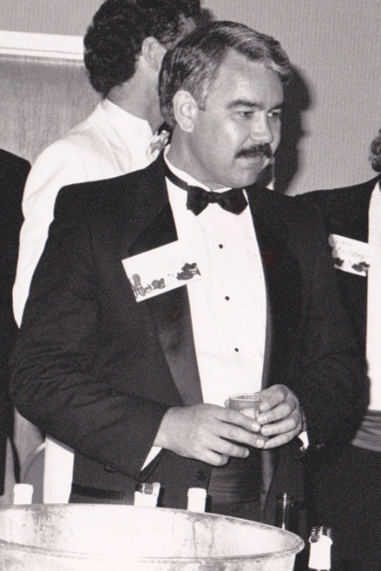

After getting us properly lubricated and anesthetized, they marched us out onto the mezzanine, where easels stood around the space with enlarged black and white, poster-sized, foam board mounted versions of our brochure pictures. We had been instructed to stand by our respective pictures and “sell” ourselves to interested women. This is where I finally learned what it was like for the opposite sex to complain about being objectified. I cannot tell you how many times my ass was patted along with two or three quick crotch grabs. I didn’t realize until later, that I also had about a dozen business cards slipped into my pockets. All the while, attentive waitresses brought us drink after drink to keep our legs like jelly and I think, from running off. I must have drunk at least 6 that I can recall, and apparently due to my heightened senses and I’m guessing thumping metabolism, didn’t seem to be affected much at all by the quantity. Yes. I felt like a side of beef on the hoof not only ready to be auctioned away but to be soon led to the slaughter!

The auction started and those of us bachelors that were awaiting our turn on the ship-shaped catwalk stage watched the preceding victims. There were noted celebrity bachelors that went for really good money (Rusty Areias Assemblyman one such example), with the average seeming to be around $500 from a rowdy female audience of around 300, mostly professional women. Whistles and cat calls were not rare and my friend Craig Hemphill, the Auctioneer was squeezing every dollar he could out of each bid.

Finally, about 11:30 that night, it was my turn as the 39th man to walk the proverbial plank. I was escorted onto the stage by a tall, leggy young beauty where I was left to walk the length of the catwalk under the bright lights, not seeing anyone in the room under the glare of the many Klieg Lights, except a few nearest the stage projection. When I came back to where I had started at the main stage, I was led to a stool to sit while my friend Craig began his enthusiastic sales pitch. His second wife Charmaine, then came over to where I was sitting and discovered I had worn a t-shirt under my dress shirt. Not liking this for whatever reason, she quickly proceeded to remove both jacket and shirt, leaving me both dumbfounded and naked from the waist up, with rental shirt studs flying all over the stage!

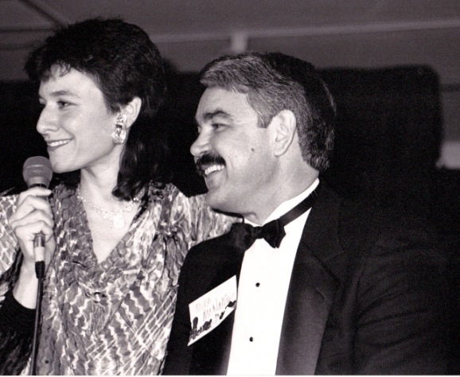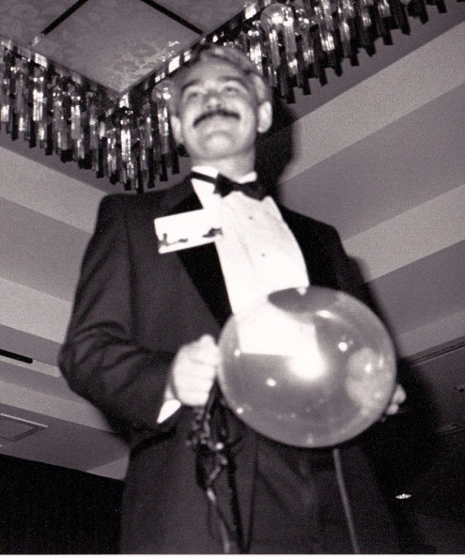
Pre-Charmaine action with Co-Host. My first walk down the stage prior to Charmaine.

Wanting to remain in control and dignified, my quick thinking kept me cool headed and without protest as I was handed my jacket, which I slung over my shoulder. I then noticed the cheers coming from the darkness, so I put on a brave smile and my friend Craig’s prodding, as gracefully as I could, proudly walked the walk one more time, coming back to by stool.

Mercifully, it was soon over and I dressed backstage and hurried away to the back of the ballroom to watch the few remaining men meet their fate on stage. We had been told earlier, that when it was all over to look for a helium-filled Mylar balloon with our name written in red carried by the winning bidder. Sure enough, not long after the final gavel, a beautiful mid-30’s blonde was headed directly for me with a balloon above her head with my name clearly visible in what looked like red lipstick smeared on the surface. Oh lucky me I thought. In a moment reminiscent of the movie “10”, she seemed to slow-motion advance, offering her hand, while announcing what seemed in an ever-so-slow manner, “Hi!! I’m Kathy!”, while beginning to turn around, she added, “And I bought you for my mother… Jean.” Did I just hear a needle screeching?

There was a great after-auction party where bachelors were thanked and treated to food and drink at a popular nightclub at the mouth of Carmel Valley, and where I got very drunk and danced to a live band until two.

Date night soon arrived and my limo driver and I picked up my date at her house and began our drive down the coast towards Big Sur in an older white Rolls Royce limosine, stopping first for a quick drink or two at the Highlands Inn’s piano bar and listening to Christopher Lee. We had a great dinner at the famous Rocky Point Restaurant, stopped once again at the Highlands Inn on our way back and then went to the top of the Doubletree to drink and dance until they closed at one taking Jean back to her front door and saying goodnight with a respectable kiss goodbye.

I got nice thank you’s from the charities we benefitted (The Family Resource Center and the Frohman Academy) and from Jean and her daughter Kathy. I did use those business cards and had a dozen really nice dates in the following month or so. Some of them were actually very nice women that I would have pursued had I not just met a gal named Cheryl that I would be with for the next 10 years.

In retrospect, what started as a very reluctant, crazy and challenging adventure, turned out to be one of the greatest experiences of my life and actually I believe a turning point for me in some ways – especially my self-esteem. It was not only good for my suffering ego, but gave be confidence for the future to face many challenges.

So I enthusiastically encourage anyone in this or any similar challenging situation, to suck it up and just do it. Because you just never know, when you might never have a Mylar balloon with your name on it and 12 business cards in your pocket if you don’t take that scary first step?

