MY CAREER STORY
May 25, 2021
This is written primarily for my daughter’s sake. So someday, when she might ask the question, “I wonder why my dad chose to be an architect?” Or “How come he decided to do that instead of something else.”
HOW I DECIDED ON BEING AN ARCHITECT
When I was growing up, the first thing I remember “wanting to be” was a fighter pilot. Why? Because around 6 or 7, I loved to draw airplanes and cars. Particulary B-26 airplanes. I recall being told how well I drew them in true perspective at that age and somehow was unique in that regard. I continued to enjoy art all through grade school and was one of a few in my various class levels that excelled at it. The first being my Kindergarten class in San Mateo (Beresford Park School), where the teacher pointed out to my parents, in front of me during a parent-teacher night, how my self-portrait varied from all the other classmates, in that, I drew full-thick limbs and fingers. As well as realistic houses, etc. As my parents studied the others, I too looked, and for the very first time, noticed how I differed from the rest of the class.
No one, really made any distinction or encouraged me or gave me any art supplies or lessons. I did note that my male classmates always wanted me to draw them my version of a 32 Roadster, which I so crudely tried to emulate from a side view. Somewhere amongst my kept paraphernalia, I have a one-third section of a chalk drawing myself and two other 6th graders (Perry Kolkowski and Craig ?) drew of the Canadian resources that were studying.
Somewhere around my 7th grade time (and almost 13) in approximately 1960, I bought my very first purchase of Hot Rod Magazine. I remember it was summer and I bought it at The Pines at Bass Lake. This edition was chiefly coverage of the premier Autorama of the time – The Oakland Roadster Show. With a very few exceptions, the hundreds of pictures were small black and white with little detail being seen. Customizing was just becoming a thing and like a lot of boys my age, along with that new-fangled rock and roll, I soaked it all up! I studied every picture tens of times to familiarize myself with the details of these cars that I was trying to emulate in some uneducated manner up until then. I even studied all the advertisements and sent off for catalogs like JC Whitney’s and Honest Charlie’s, etc. Revelation! I now knew that that thing I was drawing was actually exhaust pipes and carburetors and such. Little did I know that I was also becoming a “gear head” and commencing my love for cars to this day?
I continued drawing cars right up through grade school and into my college days. I have even saved some of those letter-sized pencil sketches in an album. I got many requests from college buddies to draw customized versions of their daily drivers or, in some cases, what they dreamt of driving. Two examples of those saved are shown scanned here.
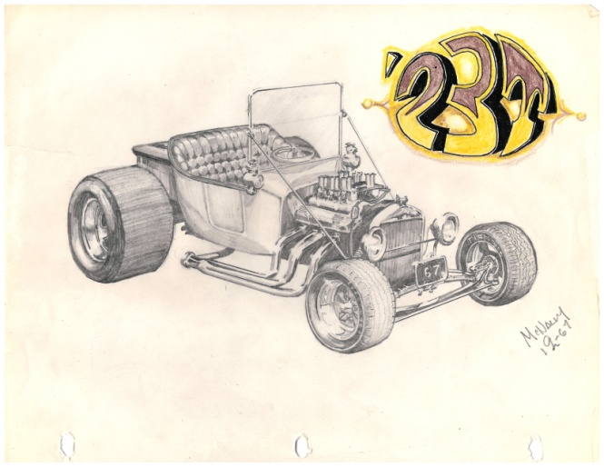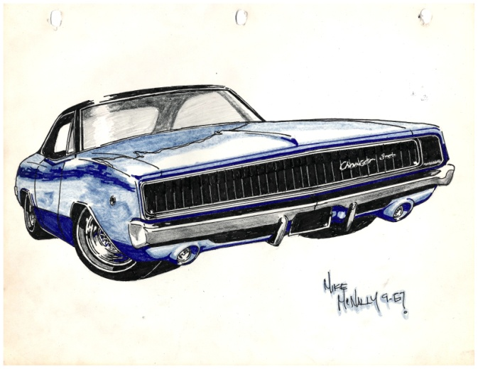

I must tell you though, that somewhere about the 8th grade, I was seriously thinking about becoming either a doctor (Pathologist as I recall) or a Catholic priest. Once every couple of months, my mother and I had this ritual of sitting down late at night over a hot chocolate or such and catch up on things, mostly about me it seems looking back now. It was one such night during the winter that I mentioned to her these two aspirations. Without laughing or giving away her surprise, she calmly questioned me about each. When she came to the priest one, she noted quite casually that priests were celibate (among other things) and if I knew that. Of course I asked her what that meant and upon learning, quickly disavowed myself of that career choice. I liked girls since four or as long as I could remember. Having never been an Alter Boy, for some reason, I was unaware of that requirement. Yikes! I just wanted to do something of a positive nature for my fellow man, which was most likely the hormones just beginning within me at the time.
In the following year I believe, our family made its first trip to Disneyland. During that visit, my sister Maureen along brother Tim got to see and visit one of the exhibits on display then – Monsanto’s “Home of the Future”
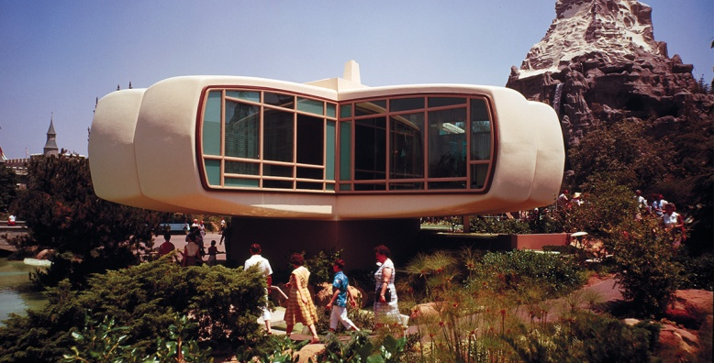
I was so taken by this vision of a near-future home that I quickly became enamored of designing such things someday. In my 9th grade year, like many schools at that age, we had avocation studies in our 1st period Home Room. Partly because of the previous years visit to the Future Home and the results of my aptitude tests I began zeroing on actually choosing to become an architect. However, I was still somewhat interested in becoming an automotive designer or a commercial artist / graphic designer. A personally written letter from someone at Ford in 1960 had soured me for the automotive designer route. Saying that annually, only about 85 people got hired by the big four car companies and then those hired likely worked all year designing a new bumper of steering wheel. Not futuristic car designs!
I took mechanical drafting in all four High School years with my 11th year spent in “architectural drafting” and that I found, loved and excelled at, becoming the teacher’s (Howard Atamian) pet. I took two a two year curriculum at Fresno City College (‘65, ‘66, ‘67) and earned both AA and AS degrees. It was always my intention to transfer to California Polytechnic in SLO and finish the next two years with a BS degree as a Junior. I never made it. I worked full time beginning in 1967 and joined the Army National Guard that fall for a six-year stint – gone full time from August ‘69 to January ’70. During those years, I did many other things besides working, but never lost my direction and goal of becoming an architect.

I did have other interests during those college years. I was either attending FCC full time or from ’67 on, working full time or, for a short period back East doing my Army training. My commitment for the state was a total of 6-years. About 5 months full time in training, six 2-week summer camps and monthly 2-day, weekend “drill” meetings. A total I once figured of about 300 days. No. Guardsmen get no VA benefits. Besides those interests noted above, I was quite social and fortunate to have had many friends both inside college and outside. I loved working on my own cars and friend’s cars. I also half built/funded a drag racing Sanger boat. I never finished that but got to the 2/3rds mark with my best friend at the time. I dated but with the exception of my first gf early on at FCC that lasted for about a year, none were serious for me though. I also delivered after school for my dad’s business after school for 2 or 3 hours daily in my HS senior year and those first two years at FCC. That gave me a vehicle to drive late in my teens and a little money to spend weekly.
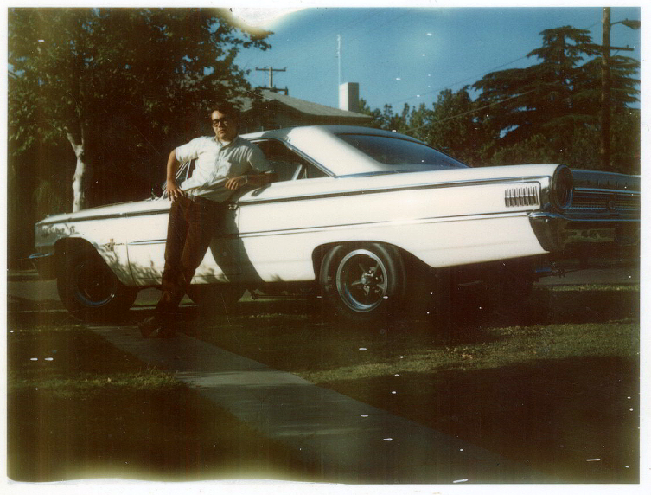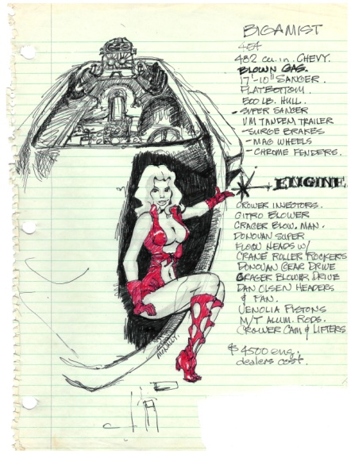
Me and my 427 cu in, 525 HP, 63 ½ Galaxie 500 XL in late 60’s. Lots of street racing! Doodled sketch of boat.

GETTING THE LICENSE
When I first started working full time, it was a two year period for a California Licensed Building Designer named Gary Boyer. I think I made about $2.40 an hour back then. I was thinking that it would be a whole lot easier to settle for an easier-to-get Building Designer license, but fortunately for me, they stopped issuing them in 1966, leaving an architectural license as my only option. I re-set my sights for that lofty piece of paper for the second time. While in Basic Training back East, I ate, drank, slept and worked with about 300 of my company’s total compliment - 200 of which, were from really, really poor areas of this country and drafted for Viet Nam. I made up my mind while there, that an education was paramount to a happy and healthy life. I have often wondered how many of those I knew actually made it back home.
After coming back from Ft, Bragg, NC and Ft. Eustis, V, I worked for Gary Boyer for a few months, then started my own drafting firm at 22. After a year of that, sold it to my partner and worked for another year for Warren Thompson ($3.50/hr.), who managed to convert his Building Designer license into that of architect while I was there. Then, BD’s were required to take and pass the architect’s exam within 5 years. Later, they changed the law to automatically let them become licensed architects in California. I often wondered about the public safety with these little educated draftsmen with a pseudo license issued after WWII that became full-fledged licensed architects by a stroke of the pen?
In November of 1971, I moved to the coast and began working for James P. Lockett ($5.00/hr.), Architect, a semi-retired [his term] architect of 60 living and running his own office in Pacific Grove. I worked for Jim for 5 years as his main draftsman on hospitals, financial buildings and a variety of other building types. I was very, very fortunate in having him as my employer because he was a natural educator and enthusiastic about helping me obtain my license. I began in his office studying for the eventual tests and that piece of paper.
In March of ’73, I married and we first lived down by the beach in Carmel. Soon thereafter, I found out that my new wife was seriously uninterested in helping me through two years in San Luis Obispo putting me through Cal Poly’s architectural school. Being the accommodating husband that I was, I understood her reasoning, and decided to teach myself instead what needed to be learned and start taking the various sections of the exam. I left Jim and started my own drafting firm above Jim’s office in Feb, of ’76, but Jim and I associated on a few projects together afterwards (The PG Library Addition and Remodel was one of them) and he continued teaching me even still. I am proud to say Jim and I remained good friends for another 23 years and he got to see me actually get that license.
To get one’s license in California, is quite an arduous process. It should be considering the seriousness of the health-safety responsibility designing public structures presupposes. If you are a graduate of a 4-yr. accredited architectural school, you get 4 years time given your education / OJT Training requirement. For me, a 2-yr. school got me only 2 years. In those years, there were three parts of the Architectural Exam: The Qualification Exam, The Professional Exam and the Oral Exam. In order to be able to qualify for the first phase, a 4-yr. graduate needed an additional 1 ½ years of on-the-job training along with the 4 years of college or 5 ½ year’s total. In my case, I needed 7 ½ years or 5 ½ OJT on top of the 2-yrs. allowed credits for my lesser education. Working for licensed architects counted as full-time credit, while that time spent with a Building Designer counted as only half-time. So by the time I qualified to take the first phase, it was near mid-70’s and I was about 28. Oh…They only gave the test once a year to about 1400 people statewide. Half were somewhere in Northern California and the other in Southern California.
The test can be taken a total of four times to complete all required portions to be passed. If you fail to pass all sections of the test after 4 tries, you must start the process all over. This is absolutely necessary, as no one passes everything in one try. There are two days to the first exam with 24 hours total – 12 each day. The first day is strictly the design portion, while the second day is 5 different sections (Structual, HVAC, Architectual History, Electrical and Plumbing). I am proud to say that of the approx. 400 examinees, I was first out the door for my Design Exam after 9.5 hours and that I simply “passed” by mail notification six months later. Oddly enough, my boss immediately believed I could “design” all of a sudden when hearing that news six months later. I think I passed one or two sections as well that first year. It took me another year to pass the remaining sections.
That completion allowed me to then take the Professional Exam, which was a total of two days also but about two hours less time. One day was totally structural engineering and the second day, codes, ADA, legal, etc. I think it took me two years to get through that phase as well. Structural engineering was my Achilles tendon, as I was weakest in my math skills. Theory I’m okay with, but working complex formulas, not so much. All sections are either “pass” or “fail”. So one never knew how strong or weak one was in any given section.
That eventual pass allowed a year later, the Oral Exam. I was grilled by three architects for a half hour at a hotel near the SF airport on all the things they knew by my test results, showed I was weakest in! I finally got my license in May of 1983! I allowed it to expire about 2015. All total, I practiced from ’67 until 2015 – 48 years. I also ran my own office from 1976 until I moved back to Fresno in 1998 for another year, working for others. I again had my own practice and also included about 3 years of flipping homes with my mother from about 2002 until 2004. See my “Profile” in this site for all of the things I did along the way. Also see “Architectural Projects” for a small sampling of some of my work photographed for my office brochure.
It was a fun and worthy career that I enjoyed for the most part and believe, I was good at. Hopefully, this history does not come off as pretentious, but merely factual? Something my daughter can read someday and she can take some measure of pride in her “old” man. I still proudly display the actual license, framed on my wall, even though I have been retired. The Dean of Architecture, Haslett for Cal Poly told me over lunch at Fisherman’s Wharf one Saturday in the late 80’s (I was the Host for our local AIA Chapter’s bi-annual design contest and he one of three judges. Warren Thompson was another ironically.) That, “Off the record, I would rather have an employee working for me who got his license the hard way like I did. The self-taught usually learned and retained more. ” I don’t know how true that is, but it worked for me!

