MIKE’S
GAZPACHO SOUP
Cold, Tomato-Based Soup
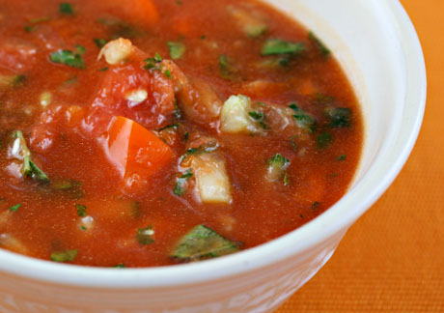
There are many versions of this recipe and ways to dress it for serving. This recipe is my version. My very first experience was in the early 80’s, while attending a League of California Cities Convention in San Diego as a Planning Commissioner for the City of Pacific Grove. About 10 of us left our Mission Valley Motel after a cocktail party, stuffed ourselves into two cabs and headed for Papagayo’s Restaurant located on Mission Bay. As the newbie, I had to order both the reservations and cabs for city officials and elected council members - so the pressure was really on my shoulders to pick a good place or never here the end of it back in PG. It was a big success and in the process I discovered for myself for that evening and for the first time, this cold tomato soup. Since then, I have made this many times, loving it best in hot summer meals with it well chilled. It is always well received.

INGREDIENTS:
- 3 – Lrg. Cloves of Garlic 1- cut in half, the other 2 minced fine.
- 6 – Lrg. Ripe Beefsteak Tomatoes (or 10-12 Smaller Tomatoes) – Lrg. dice.
- 2 – Lrg. and Firm Cucumbers – Remove skin, and remove seeds or not. Lrg. dice.
- 1 – Lrg. Green Bell Pepper – seeds removed – Lrg. dice.
- 4 – Med. Stalks of Celery, w/ tops and bottoms removed, washed and Lrg. chop.
- 1 – Sml. Can of Diced Green Chiles (Optional).
- 1 – Lrg. Can of Tomato, V-8 or Clamato Juice.
- 2 – Tbsp’s. Virgin Olive Oil.
- 2 – Tbsp’s. Red Wine Vinegar (More if desired).
- 2 – 4 Tsp’s. Salt.
- 1 – 2 Tsp’s. Fresh Ground Black Pepper.
- 1 - Tsp. Ground Oregano.
- 1 – Tsp. Ground or whole Cumin Seeds.
- Juice of 2 Lemons.
- 1 – Lrg. Purple Onion (or Maui or Vidalia) – Lrg. dice.
- 3 – Green Onions – cleaned and rough chopped.
- 1 – Cup Cilantro – rough chopped. Note: Save some for Garnish.
- 2 – Tbsp’s. Worchester Sauce.
- Optional:
  - 1 – Sml. Jicama – small diced for topping sprinkle.
  - Red Food Color as desired for increasing deeper coloring.
  - 1 Red Pepper – seeds removed – Lrg. dice. Note: Both Peppers could be small diced and instead of adding to soup base, used as a garnish to sprinkle on top.

DIRECTIONS:
- In a large mixing bowl, combine all of the above “base” ingredients, toss together and ladle into a food processor or blender and “puree’” until consistency desired. I prefer my texture somewhere between a chunky salsa and the average soup.
- Rub inside surface of a large glass bowl with halves of Garlic. Place processed soup in this container and cover. Place in refrigerator and chill for at least 3-hours.
- Serve in colorful bowls and garnish as desired.
- Bowl can be kept cold by placing on bed of ice.

